**Marketing Analytics Project Report**

**Title: Black Friday Shopper Segmentation Analysis**

**December 9, 2024**

**Table of Contents**

1. Background and Research Objectives
2. Research Method
3. Findings and Marketing Insights
   * Segmentation and Targeting
   * Positioning
   * Promotional Effectiveness
4. Segmentation Analysis Methodologies
5. Marketing Recommendations
6. Conclusion
7. Appendix
8. References
9. **Background and Research Objectives**

**Background:**  
Black Friday is one of the most prominent shopping events of the year, with consumers eagerly waiting for deals and promotions. Retailers face significant challenges in understanding shoppers' diverse needs and behaviours. This diversity can result in missed opportunities when campaigns are not tailored effectively. Understanding consumer segmentation can improve targeting, leading to better customer satisfaction and higher returns on marketing investment.

The rise of online shopping has further diversified consumer behaviour. While some shoppers prioritize convenience and discounts, others value the tactile in-store experience. Additionally, technological advancements and social media influence have shifted how shoppers discover and interact with deals. Addressing these dynamics requires precise segmentation and actionable insights.

**Research Objectives:**

1. Identify and profile distinct shopper segments based on demographic, behavioural, and technological characteristics.
2. Analyze the motivations, promotional preferences, and purchase behaviours of each segment using discriminant variables.
3. Recommend actionable marketing strategies for the identified shopper segments to enhance campaign effectiveness and maximize engagement.

2.**Research Method**

We conducted a survey for Black Friday Shopping combining different factors of how users will do their shopping which will help determine the data in segmentation and discriminant data:

**Categorizing the data into Segmentation and Discriminant Data :**

**Columns that qualify as segmentation data:**

1. What is your age group? (Demographic)

2. How do you plan your Black Friday shopping? (Behavioral)

3. How often do you shop during Black Friday? (Behavioral)

4. How do you prefer to shop on Black Friday? (Behavioral)

9. What is your preferred device for online Black Friday shopping? (Behavioral/Technological)

14. Which categories do you shop for most during Black Friday? (Behavioral)

15. How much do you typically spend during Black Friday? (Spending Behavior)

**Columns that qualify as discriminant data:**

5. What motivates you to shop during Black Friday? (e.g., Discounts, Convenience, Gift Shopping, New Product Releases) ( Help distinguish between different shopper types)

6. How important are discounts when deciding what to buy? ( differentiates bargain hunters from other types of shoppers)

7. What type of promotions do you prefer?

Helps classify people based on promotional preferences.

8. Where do you usually find out about Black Friday deals?

Distinguishes between shoppers influenced by social media, emails, or in-store ads.

10. Do you typically prepare for Black Friday shopping?

Separates impulsive shoppers from planners.

12. What influences your Black Friday purchase decisions the most?

Identifies key factors like price, reviews, or availability.

13. How likely are you to buy items as gifts during Black Friday?

Differentiates gift shoppers from personal shoppers

**Methodology:  
Segmentation Approach**: Hierarchical clustering was applied using standardized segmentation variables to ensure proper weighing, enabling effective identification of customer segments."  
**Discriminant Analysis:** The descriptors provide critical insights into how different segments behave and can help predict segment membership based on available data. Including the descriptors ensures a comprehensive understanding of the segmentation analysis and its practical applications.

**Sample Details:**

* Sample Size: 60 respondents were collected through a structured Google Forms survey.
* Variables:
  + Segmentation Variables: Age, shopping plans, frequency, preferences, device usage, categories purchased, and spending.
  + Discriminant Variables: Motivations, preferred promotions, deal sources, preparation behaviors, purchase influencers, and gift likelihood.

Limitations:

1. Sample size limits generalizability.
2. Self-reported data may introduce bias.
3. Exclusion of external market factors, such as competitor strategies or economic conditions.
4. The segmentation is based on a limited set of variables, which may not capture all relevant dimensions of customer behavior or preferences.
5. Some descriptor variables were excluded due to high collinearity, potentially reducing the richness of insights from descriptor analysis.
6. The principal component analysis (PCA) used for visualization captures only a portion of the variance (e.g., 36.3% for segmentation variables), meaning some segment differences may not be fully represented

**3.Findings and Marketing Insights**

**Segmentation and Targeting :**

The segmentation analysis initially explored a three-segment solution to evaluate how the data could be divided into distinct clusters. The three clusters were found to be evenly distributed, each comprising 33% of the population. However, upon closer examination, this segmentation did not provide clear or actionable distinctions between the clusters in terms of customer behavior and spending patterns.

To address this, a two-segment solution was applied. This approach revealed more meaningful insights, as it highlighted clear behavioral and spending differences between the two clusters. The two-segment model provided a better balance between statistical fit, managerial relevance, and targetability, making it a more effective choice for understanding and addressing customer needs.

**Dendrogram Analysis**

**Two-Cluster Solution**

* Shows a clearer separation between the two main branches
* More balanced height between clusters, indicating natural grouping
* Creates distinct segments with clear shopping behavior patterns:
  + Segment 1 (33%): Tech-savvy smartphone users who prefer electronics
  + Segment 2 (67%): Traditional shoppers focusing on apparel and using laptops

**Three-Cluster Solution**

* Shows more fragmentation of the data
* The third cluster appears to be artificially created by splitting what could be a natural group
* Creates potentially redundant segments with overlapping characteristics

**Statistical Evidence**

The two-cluster solution is superior because:

1. **Cleaner Separation:** The dendrogram shows a more natural break at the two-cluster level, suggesting this is the most appropriate number of segments.

1. **Segment Sizes:**
   * Two clusters: 20 and 40 members (33% and 67%) - more manageable distribution.

* + Three clusters: 20, 20, and 20 members (33% each) - artificially equal sizes

**Segment Profiles:**

1. Segment 1: Tech-Savvy Bargain Hunters (33 percent)
   * Age: Primarily 18–35 years
   * Shopping Channel: 90 percent prefer online shopping
   * Device Usage: 80 percent use smartphones
   * Spending: 65 percent spend over $500
   * Product Focus: Electronics dominate purchases (80 percent)
2. Segment 2: Traditional Apparel Shoppers (67 percent)
   * Age: 26–45 years
   * Shopping Channel: 60 percent prefer in-store shopping
   * Spending: 70 percent spend $100–$500
   * Product Focus: Apparel purchases dominate (60 percent)

**3.Interpretability:** The two-cluster solution provides more actionable segments with clearer distinctions in shopping behavior and preferences

**Marketing Implications**

The two-cluster solution offers better practical application because:

* Easier to develop targeted marketing strategies for two distinct groups
* More cost-effective implementation of marketing campaigns
* Clearer differentiation between customer segments for resource allocation

**Positioning :**

**Perceptual Map Analysis:**

Below image shows statistical differences in Black Friday shopping behaviors and preferences between two groups, indicated by red (Lower) and green (Higher) bars, with gray bars showing non-significant differences.

**Key Findings**

**Shopping Planning**

One group tends to make impulse purchases without planning

The other group prefers to decide their purchases on the day of Black Friday

**Device Preferences**

Significant differences exist in device preferences for online shopping

One group shows higher smartphone usage

The other group demonstrates greater laptop/desktop computer usage

**Shopping Categories**

Notable differences appear in shopping categories:

Electronics shopping shows a significant difference between groups

Apparel and "Other" categories also show statistical differences

**Statistical Significance**

The color coding in the visualization indicates:

Red bars represent lower values (p<.05)

Green bars represent higher values (p<.05)

Gray bars indicate non-significant differences (n.s.)

**Segmentation Analysis Using Descriptors:**

Including descriptors in segmentation analysis enhances predictive accuracy by linking segment membership to variables like promotional preferences, deal discovery methods, and shopping motivations. This provides actionable insights for managers to develop targeted marketing strategies tailored to specific customer segments. Additionally, descriptors highlight statistically significant differences between segments, ensuring a more robust and reliable segmentation model.

**Dendogram Analysis :**

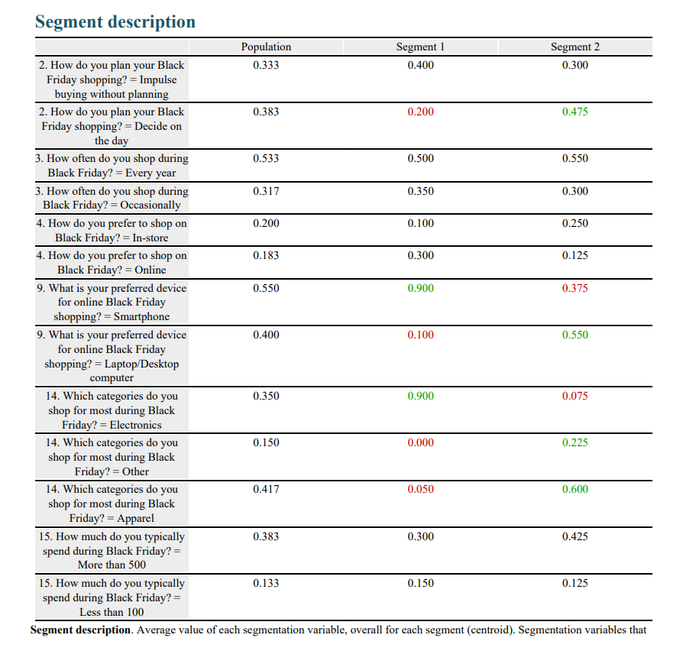

**Positioning**

Perceptual Map Analysis:  
The perceptual map revealed that Segment 1 aligns strongly with online shopping and high-value electronics, while Segment 2 aligns with in-store shopping and apparel purchases.

**Positioning Recommendations:**

1. Digital-first campaigns for Segment 1, focusing on flash sales and exclusive tech deals.
2. In-store campaigns and personalized promotions for Segment 2.

**Promotional Effectiveness**

* Flash Sales: Highly effective for Segment 1, with 80 percent finding these promotions attractive.
* Personalized Discounts: Effective for Segment 2, with 60 percent responding positively to tailored offers like bundled apparel deals.

**Segmentation Analysis Methodologies**

Segmentation analysis methodologies involve identifying distinct customer groups based on shared characteristics. This process ensures that marketing strategies are tailored to meet specific consumer needs effectively.

1. Clustering Techniques
   * **Hierarchical Clustering**:  
     This method builds a hierarchy of clusters by grouping respondents based on their similarities.
     + Calculate distances (e.g., Euclidean distance) between respondents.
     + Group similar respondents iteratively until all data points are merged into clusters.
     + Use a dendrogram to visualize the process and decide the optimal number of clusters.
2. Standardization of Data
   * All segmentation variables were standardized to ensure equal contribution, preventing variables with larger ranges (e.g., spending) from dominating the analysis.
3. Determining the Optimal Number of Clusters
   * **Scree Plot**: Identifies the “elbow point,” where additional clusters add minimal explanatory power.
   * **Managerial Interpretability**: Focuses on actionable segmentation that balances statistical and practical relevance.
4. Discriminant Analysis
   * Profiles clusters using discriminant variables like motivations, promotional preferences, and preparation behaviors to ensure statistical and practical distinctiveness.
5. **Marketing Recommendations :**

**1.** Target Segment 1 with mobile-optimized digital campaigns featuring flash sales and exclusive tech bundles.

Design loyalty programs for Segment 2, focusing on personalized in-store experiences and promotions tailored to family shoppers.

Introduce hybrid promotions (online and in-store) to cater to overlapping characteristics identified in the 3-segment solution.

**2**. **Promotion Strategies :**

* Emphasize flash sales as they appeal across segments (preferred by ~70% of respondents).
* Use "buy-one-get-one" deals selectively for apparel-focused segments.
* Offer loyalty rewards to retain high-value customers who shop every year.

**3. Communication Channels :**

* Social media is a key channel for reaching smartphone users in Segment 1.
* Email marketing is effective for traditional shoppers in Segment 2 who use laptops/desktops.
* Word-of-mouth campaigns can be encouraged through referral discounts.

**4.Preparation and Motivation Insights:**

* Many shoppers do not prepare extensively for Black Friday; capitalize on this by promoting deals closer to the event date.
* Discounts remain the primary motivator; ensure that promotional messaging highlights savings prominently.
* For gift-focused segments, emphasize holiday gift bundles and convenience.

**5. Long-Term Customer Engagement :**

* Build segment-specific loyalty programs:
* For tech-savvy shoppers: Points systems redeemable on electronics.
* For traditional shoppers: Apparel-focused rewards with seasonal benefits.
* Collect feedback post-event to refine future campaigns based on segment-specific satisfaction levels.

1. **Conclusion:**

The analysis highlights the importance of understanding distinct shopper behaviors during Black Friday. Segment 1, comprising tech-savvy bargain hunters, demonstrates a strong preference for online shopping, high-value electronics, and flash sales. This segment responds well to digital-first strategies and exclusive deals.

Segment 2, representing traditional apparel shoppers, values in-store experiences, personalized promotions, and quality over price. By tailoring marketing strategies to these distinct segments, retailers can maximize customer engagement, drive sales, and optimize resource allocation during Black Friday.

**7**.**Appendix**

The appendix includes the survey questionnaire and visualizations such as spending patterns, segmentation distributions, and perceptual maps.

**8.References**

Survey Data: [<https://docs.google.com/forms/d/e/1FAIpQLSeIBj9ksAhLp2ZNDXwJIFe_B_hBbwnfs6PcMdctljM7-WctFg/viewform>]

Enginius Tool Documentation

Supporting Literature on Market Segmentation and Targeting